**Project Plan**

***Video call system for third year internship***

*SVb employees*

<<

*This template can be used for all projects, especially software engineering projects. Chapters or parts that are not applicable can be removed.*

*Text in italic is background information and must be removed in the final version of your project plan.*

*Note that this is a template and can be changed for own purposes, e.g. you can adapt the layout to the layouts as used at the company of your internship.*

*For your project name, think of a name that highlights the most relevant aspect of your project, and specify whether it is about graduation internship or third year internship.*

>>

|  |
| --- |
| **Date : 4 september 2023** |
| **Version : 0.1** |
| **State : In progress** |
| **Author : Tony Jiang** |

#### Version history

|  |  |  |  |  |
| --- | --- | --- | --- | --- |
| **Version** | **Date** | **Author(s)** | **Changes** | **State** |
| 0.1 | 4 sept 23 | Tony Jiang | Initial start of document | In progress |
|  |  |  |  |  |
|  |  |  |  |  |

**Distribution**

|  |  |  |
| --- | --- | --- |
| **Version** | **Date** | **Receivers** |
|  |  |  |
|  |  |  |

Contents

1. Project assignment 4

1.1 Context 4

1.2 Goal of the project 4

1.3 Scope and preconditions 4

1.4 Strategy 5

1.5 Research questions and methodology 5

1.6 End products 6

2. Project organisation 7

2.1 Stakeholders and team members 7

2.2 Communication 7

3. Activities and time plan 8

3.1 Phases of the project 8

3.2 Time plan and milestones 8

4. Testing strategy and configuration management 10

4.1 Testing strategy 10

4.2 Test environment and required resources 10

4.3 Configuration management 10

5. Risk 11

5.1 Risk and mitigation 11

# Project assignment

## Context

*<<Describe the company and context briefly. >>*

The company called ITP Caribbean tasked me to create 2 or 3 solutions for a video call system for their application. ITP stands for Information Technology Partners. They provide IT solutions in consultation for their customers. ITP Caribbean is located in Rumbastraat in Oranjestad, Aruba. The Company activities are IT Consultancy, developing software solutions, network administration serves and health care. They’re currently working with one of their largest clients, SVb (Sociale Verzekeringsbank in Aruba) to create a video call system on the application. The application is called PRAS, it stands for Pensioen Registratie en Administratie Systeem.

## Goal of the project

*<<Describe the goal of the project. Take into account:*

*The why, what is the reason for doing this project?*

*What would the new preferred situation look like?*

*What are the advantages of this project?*

*How does this project add value to the company/context?*

*Which possibilities does the ICT product offer that the project will realize?*

*>>*

* Why is the project being done?

Currently one of the SVb department have to determent if the retirees that live abroad are still alive. The determination if a person is still alive, is done by using a WhatsApp video call facility on a tablet, which is a bit of a hassle to do. The tablet has to be operational and up to date. The employees have to search for the retired person on WhatsApp, which need a bit of manual work and could be error prone.

* What would the new preferred situation look like?

The preferred situation is to have the video call system on the PRAS application system, to have everything easy to access and easy to use in one system. The system would provide proper user interface.

* What are the advantages of this project?

The advantages of this project are to provide accuracy and efficiency to the SVb employees who needs to make a call video to the retirees that are living abroad. The system will also reduce human errors.

* How does this project add value to the company/context?

The project adds value to reduce the use of tablets and reduce the cost to buy new tables and maintain it. They only need to use the PRAS application system to manage the video calls and everything they need to do for checking up on retirees is on the PRAS application.

* Which possibilities does the ICT product offer that the project will realize?

ICT products offers a better way to make a video call on the PRAS application. It also offers hands in in the application, no more external technology or software to make e video call to the retirees.

## Scope and preconditions

*<<What activities and which end products (to what extent or quality) belong to the project, and which don’t.>>*

|  |  |
| --- | --- |
| **Inside scope:** | **Outside scope:** |
| 1. Come up with 2 or 3 solutions for video call system. | 1. Ensuring code quality and test |
| 1. Create the prototype on the PRAS application. | 1. Create wireframe |
| 1. Familiarize with the application and the process. | 1. Create research document |
|  | 1. Create C4 architecture diagram |

*<< Indicate any preconditions. E.g., think of technology choices that have already been made by the company. Note that you are also expected to retain a critical, but constructive, mindset for choices already made >>*

## Strategy

*<< Describe the strategy for your project (the approach). E.g., waterfall, or an agile approach like scrum, and justify the choice. >>.*

The approach for the project of building a video call system for the PRAS application can be an agile approach like scrum. Scrum is a popular project management framework that is designed to deliver high-quality software in an iterative and incremental manner. The Scrum methodology is ideal for complex projects with rapidly changing requirements, which is applicable in the case for a video call system.

The Scrum approach will enable me to deliver value quickly by breaking down the project into smaller chunks called sprints. Each sprint will deliver a working piece of software that can be demonstrated to the stakeholders. This allows for constant feedback and course correction throughout the project, which will help ensure that the system meets the needs of all stakeholders. Additionally, the Scrum methodology promotes transparency and collaboration amongst the stakeholders, which will help keep everyone aligned and working towards a common goal.

In contrast to a traditional waterfall approach, where each phase of the project is completed before moving on to the next, the Scrum approach encourages continuous development and testing. This helps to identify issues and problems early in the project, which can be addressed quickly, reducing the risk of costly rework later on.

In summary, the Scrum approach is suitable for the video call system project as it allows for flexibility, constant feedback, and collaboration, ultimately leading to a higher quality end product that meets the needs of all stakeholders.

## Research questions and methodology

*<<*

*Describe the research questions that are most relevant to your project. For each research question, describe the approach and/or methodology. Use the Dot Framework to specify strategies and methods - see* [*http://www.ictresearchmethods.nl*](http://www.ictresearchmethods.nl) *for details.*

*Note that research is not only part of the initial phases (like analysis) of the project, but runs throughout the whole project. E.g., in the realization phases, you will probably do research in the Workshop and Lab context.*

*Realize that during the project your research questions may change, and that new ones will come up. That normal for any project, and is not a problem as long as you involve the right stakeholders, and keep your deliverables updated.*

*>>*

* Research question 1: How should the video call facility work in the PRAS system?

Methodology: Document analysis, Interview

This is to look at the documentation on what the client (SVb) want based on the interview they did

with the company (ITP Caribbean) or any information that the company has gathered and documented.

Interviewing the company on any information or questions about the PRAS system or the video call

system is also, helpful.

* Research question 2: What video call system are there?

Methodology: Available product analysis, Literature study, Brainstorm.

This is to look if there are any available products online, like any information to make a video call system.

Any general information and best practices in making a video call system is helpful. Also, to come up with

some ideas on how to make a video call system.

* Research question 3: Which video call system can be implemented based on the requirements?

Methodology: IT architecture sketching, Requirements list, Prototyping.

IT architecture sketching is to get an idea on how everything is set up and how it would be implemented

with the requirements in mind. Build a prototype would also give more insight on how to implement a

video call system into the application to make other possible video call system prototype for the

application.

* Research question 4: Which video call system benefit a better user experience?

Methodology: Usability testing, Unit test, Persona.

This is to test out everything from unit test, acceptance test, usability test for any unexpected issue that

could happen with the users while using the video call system. Acting as a certain user that is going to

use the application is also helpful, to get an idea on what the user is experiencing when using the video

call system and to help out in improve it as much as possible.

## End products

*<< A Product Breakdown Structure (PBS) lists the end products that you realize, including a description of each product. In software engineering, the products are more than just the project plan and the application itself. E.g., requirements documents, architecture documents, research reports and test reports are all end products. These are all important products that are required for effective handover. They are also necessary for further maintenance and follow up-projects. The PBS can change during the course of the project.>>*

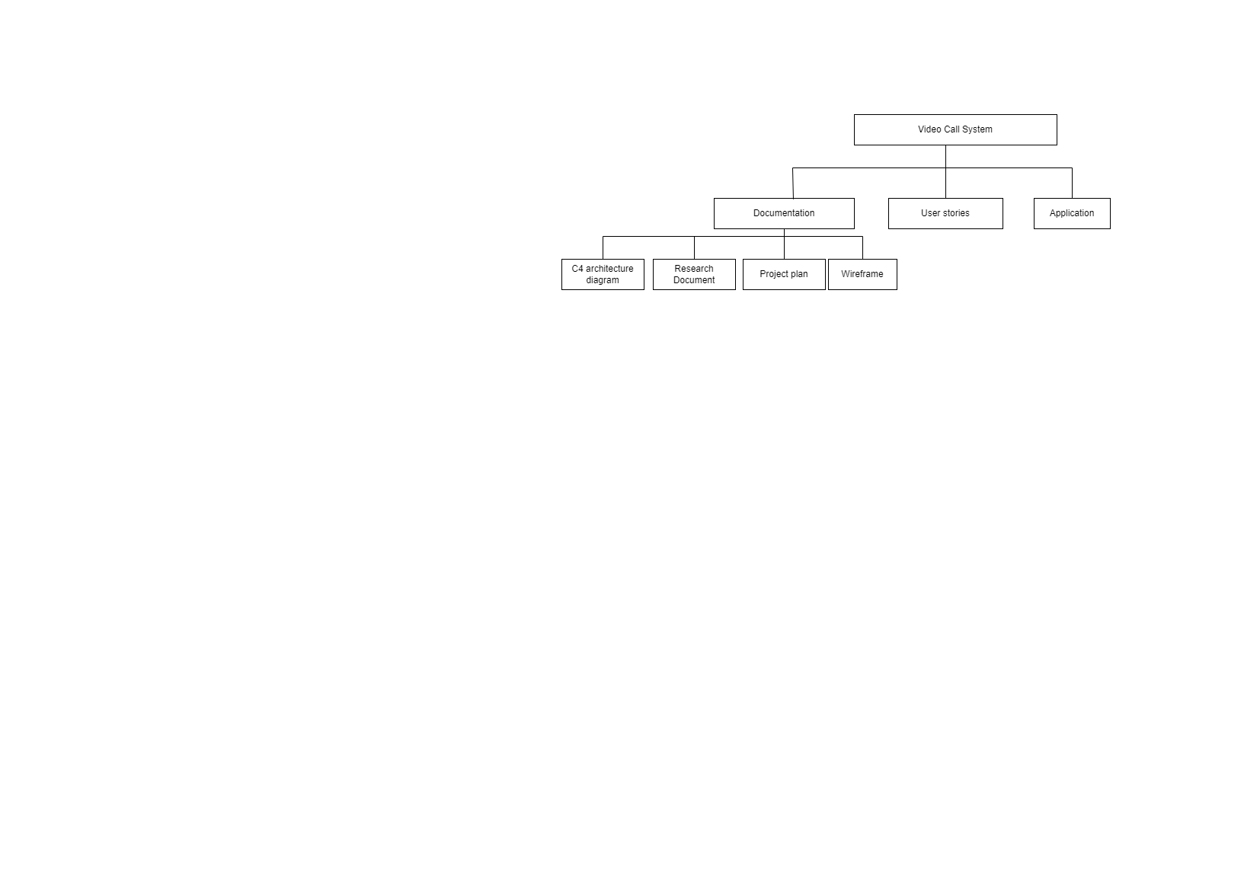

# Project organisation

## Stakeholders and team members

*<<Indicate all stakeholders and team members for your project. For each stakeholder indicate the role for your project. Note that the role that a person has for your project is different from the function the person has. E.g., someone with the function “department manager of department X” can have the role of product owner for your project.*

|  |  |  |  |  |
| --- | --- | --- | --- | --- |
| **Name** | **Contact** | **Abbreviation** | **Role and functions** | **Availability** |
| Edwin Roos | [e.roos@itpinternational.com](mailto:e.roos@itpinternational.com) | E. | Company mentor | Monday to Friday from 8:00 till 17:00 |
| Olga Makoveeva | [o.makoveeva@fontys.nl](mailto:o.makoveeva@fontys.nl) | O. | Frist assessor (University tutor) |  |
| Tony Jiang | [t.jiang@student.fontys.nl](mailto:t.jiang@student.fontys.nl) or [T.Jiang@itpinternational.com](mailto:T.Jiang@itpinternational.com) | T.N.P. | Intern developer | Monday to Friday from 8:00 till 17:00 |
|  |  |  |  |  |
|  |  |  |  |  |
|  |  |  |  |  |

## Communication

*<< Indicate the meetings and other channels of communication that you have established, or that you use for your project. Think of communication with all stakeholders including company supervisor, teachers, etc.*

*In which manner does each communication take place? Think of the goals, the location (or whether it should be online), the timing and frequency, and the attendee list>>*

Meeting with the company mentor

* Location: On company building.
* When: From 8:00 till 17:00 on Monday to Friday.
* Goal:
* For questions, if something isn’t clear.
* For help, if help is needed to fix any issue or to figure out a solution.
* For feedback on how everything is going on the project.

Meeting with the first assessor

* Location: Teams meeting.
* When: Planned date first.
* Goal:
* For questions, if there is an issue.
* For weekly meetings on how the project is going.

# Activities and time plan

## Phases of the project

*<< Describe the main phases of your project. Even in a scrum project, you should specify at least the components at the beginning and end phases like problem analysis in the beginning, as well as handover, evaluation, reflection, and wrap up at the end.*

*For internship projects, reserve sufficient time for developing/maintaining the portfolio/thesis.*

*>>.*

The phases of the project are in sprints. Each sprint I have to deliver and present the product to the company mentor. Each sprint takes 3 working weeks, with the exception of the last sprint which has 2 working weeks before the end of the internship. The whole project should be finished in 7 sprints. Below it is possible to see the supposed milestones and correlating activities for the project.

* Sprint 1: Initial planning and research – Plan and create every document that are needed to create the project and do some research on the project.
* Sprint 2: Setup and get acquaintance with the initial environment and continue to do research – Setup everything that is needed to start programing on the project and get acquaintance with everything new that is needed for the application. Also continue to do research on the project.
* Sprint 3: Making the prototype – Start making prototypes of the project.
* Sprint 4: Improve, implement and create new prototype – Improve the project and implement some stuff based on the feedback and create new prototype for another solution.
* Sprint 5: Improve and implement – Improve and implement based on the feedback.
* Sprint 6: Improve and implement - Improve and implement based on the feedback.
* Sprint 7: Finish up everything – Finish everything up from the project.

## Time plan and milestones

*<< For a waterfall project you can indicate the phases and milestones below (can be adapted as required).*

*For an agile project, describe how the artefacts are planned. E.g., length of sprint (with justification), organization of stand up, demo, retrospective.*

*>>*

|  |  |  |
| --- | --- | --- |
| **Phasing** | **Start date** | **Finish date** |
| 1. Sprint 1 | 4 Sep 2023 | 22 Sep 2023 |
| 1. Sprint 2 | 25 Sep 2023 | 13 Oct 2023 |
| 1. Sprint 3 | 16 Oct 2023 | 3 Nov 2023 |
| 1. Sprint 4 | 6 Nov 2023 | 24 Nov 2023 |
| 1. Sprint 5 | 27 Nov 2023 | 15 Dec 2023 |
| 1. Sprint 6 | 18 Dec 2023 | 12 Jan 2024 |
| 1. Sprint 7 | 15 Jan 2024 | 26 Jan 2024 |

# Testing strategy and configuration management

## 

## Testing strategy

*<<Which testing strategy do you envision? E.g., on which levels will testing take place? Consider that you could choose unit, component, integration, system, or acceptance testing.*

*Justify your strategy, and also set goals where relevant. E.g., percentage code coverage for the relevant unit tests. For each of the planned tests, indicate what will be automated and what not.*

*Also think of quality testing setups like, e.g., Sonarqube.*

*>>*

* Unit test: This test will be used to test the code behavior. The unit test will be done for each functionality.
* Acceptance test: This test will be used to heck if the stories acceptance criteria were met.

## Test environment and required resources

*<< Describe the test environment. E.g., do you envision a DTAP (Development, Testing, Acceptance, Production) environment. Can you make use of a CI/CD environment or will you develop your own?*

*It often helps to use a picture to visualize the test environment.*

*If you already know, describe which resources are required for realization and testing. Think of hardware, cloud environments and specific tooling required for development and testing.*

*>>*

Environments

* The tests are performed on a local machine (laptop) from the company.
* The company server test

Tools

* Postman

## Configuration management

*<< Describe the project approach with respect to version management (e.g. your GIT repository). This might include things like tooling, branching strategy, promotion-, release- and baseline strategy.*

*Also, when relevant, think of a mechanism to deal with change requests and problem reports.>>*

The company uses SVN to manage all their source code. SVN stands for Apache Subversion or also known as Subversion. Subversion is a revision control system, where it’s responsible for managing changes to the computer programs, documents, large websites, or other collections of information.

SVN workflow

Tools

* TortoiseSVN or VisualSVN
* Working copy of repo: This contains a working copy of the main repository.

# Risk

## Risk and mitigation

*<< Investigate and define all risks affecting the project. For each risk indicate what has been done, or will be done during the project, to prevent the risk from being actualized, and define the mitigation actions, such as what you plan to do if the risk actually eventuates. Think both from an organizational perspective about risks (e.g. sudden unavailability of the company mentor) and also from a content perspective (e.g. what happens if your research shows that it is a better to purchase an application than to develop it as a major part of your internship).*

*In a more elaborate version, you can also label the risks with their chance of occurrence and impact. The advice is to focus on risks that have both a real chance of eventuating and some considerable impact. Direct risks, like what to do if your company supervisor is not available anymore, should always be described, as they have happened in the past quiet regularly.*

*>>*

|  |  |  |
| --- | --- | --- |
| **Risk** | **Prevention activities** | **Mitigation activities** |
| 1. Sick. | Call in for sick day. If possible, work at home. | Find a way to work for the extra time lost with the company mentor. |
| 1. Health checkups or personal reason. | Call or make an appointment with the company mentor, so that they know. | Work extra time that you have lost and schedule it with the company mentor. |
| 1. Company mentor or first assessor isn’t available due to personal reason or sick. | Do not leave everything for the last moment. Assume that this kind of situation might happen. | Ask company mentor or first assessor when they are available. Schedule a meeting as soon as possible. |
| 1. Falling behind on the deadline for the deliverables. | Always check on the agile scrum board on what to deliver on that sprint and the deadline. | Work overtime to fulfill the deliverables and let the company mentor know, to come up with a solution for this |
| 1. Programing environment has an error or problem. | Ask colleagues for help on how to fix it and or find a solution online. | Let the company mentor know, so that we can come up with a solution for this problem. |
| 1. Company mentor leaving the company for personal reason. | No action can be taken. | Let the first assessor know about this and ask colleague for help on who to talk to about this to find a solution for this. |